32F Frequency Converter Instruction
wiring diagram：
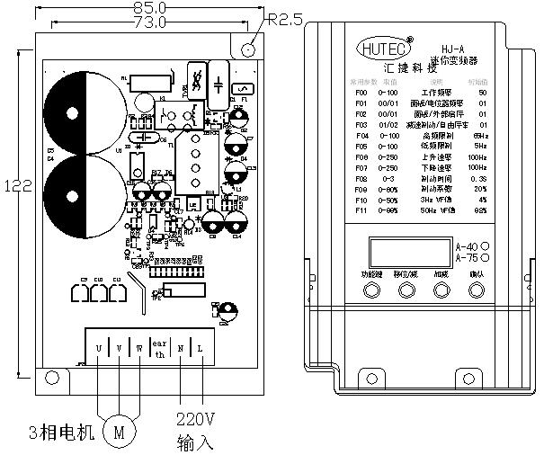bare size：long135mm*wide85mm*high86mm
size：long139mm*wide86mm*high90mm
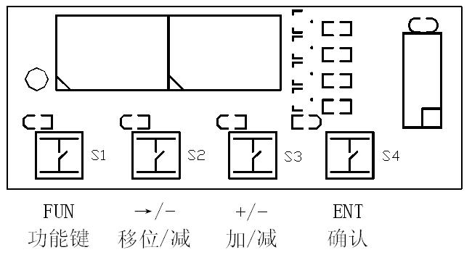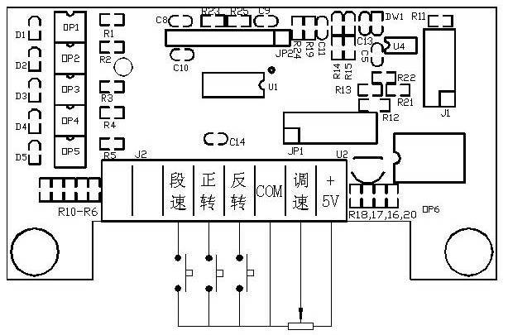

Parameter specification：

parameter | Parameter specification | Parameter rang |  | default | For note
F0 | Working frequency | 0～400Hz |  | 50Hz
F1 | Working frequency source | 0，Panel keyboard  1, external potentiometer  2, panel potentiometer |  | 2
F2 | Working frequency source | 0，Panel keyboard  1，external port |  | 0
F3 | Stop way | 0，slow stop  1，braking stop  2，Inertia stop |  | 0
F4 | Maximum operating frequency | 0～400Hz |  | 65Hz
F5 | Lowest operating  frequency | 0～400Hz |  | 5Hz
F6 | Increase speed of  Frequency | 1～500Hz/S |  | 20Hz/S
F7 | Decline speed of  Frequency | 1～500Hz/S |  | 20Hz/S
F8 | Braking time | 0-3S |  | 0.3S
F9 | Braking coefficient | 0～60％ |  | 20％
F10 | Lowest output voltage | 0～80 V |  | 10V
F11 | Middle voltage | 0～220 V |  | 65 V
F12 | highest output voltage | 0～220 V |  | 220V
F13 | Lowest frequency | 0～400Hz |  | 3Hz
F14 | Middle frequency | 0～400Hz |  | 15Hz
F15 | Highest frequency | 0～400Hz |  | 50Hz
F16 |  | 0 | Mi1：Forward/Stop;  Mi2: Reverse/Stop | 0
 | Mi1 and Mi2 function set | 1 | Mi1：Run/Stop;  Mi2: Reverse/ Forward
 |  | 2 | Mi1,Mi2,Mi3:three-wire system
 |  | 3 | Mi1：Forward/Stop
F17 | Mi1 Function Set | 0: non-function  1：stop when off  2：stop when on  3：Abnormal clear |  | 0
F18 | Mi2 Fun Set | 0：non  1：Stop when off  2：Stop when on  3：Abnormal clear  4：Speed BIT0  5：Speed BIT1  6：Speed BIT2  7：Speed BIT3  8：forward move  9：reversal move |  | 0  0 | Mi5 with MO Function alternative, can’t use meanwhile
F19 | Mi3 Fun Set
F20 | Mi4 Fun Set
F21 | Mi5 Fun Set
F22 | Speed 1 | F5～F4 |  | 0
F23 | Speed 2 | F5～F4 |  | 0
F24 | Speed 3 | F5～F4 |  | 0
F25 | Speed 4 | F5～F4 |  | 0
F26 | Speed 5 | F5～F4 |  | 0
F27 | Speed 6 | F5～F4 |  | 0
F28 | Speed 7 | F5～F4 |  | 0
F29 | Speed 8 | F5～F4 |  | 0
F30 | Speed 9 | F5～F4 |  | 0
F31 | Speed 10 | F5～F4 |  | 0
F32 | Speed 11 | F5～F4 |  | 0
F33 | Speed 12 | F5～F4 |  | 0
F34 | Speed 13 | F5～F4 |  | 0
F35 | Speed 14 | F5～F4 |  | 0
F36 | Speed 15 | F5～F4 |  | 0
F37 | Reach the frequency | F5～F4 |  | 0
F38 | Mo function set | 0：Run H，Stop L  1: Equal set frequency H，else L  2: Frequency equal 0，H，else L  3：≧”F37” H，else L  4: Fault H，Normal L  5: AO |  | 0 | Mi5 with MO Function alternative, can’t use meanwhile
F39 | Current limit | 2～5A |  | 3.5A
F40 | Speed ratio | 1～120（1 is frequency） |  | 1
F41 | Speed offset | 0～200 |  | 100
F42 | Direction of timing | 0：Count down；1：Timing |  | 0
F43 | Carrier frequency | 8～15kHz |  | 8
F44 | power saving | 0～30 |  | 0
F45 | ”F21” parameter 8 | F5～F4 |  | 0
F46 | ”F21” parameter 9 | F5～F4 |  | 0
Press FUNC key，you see F 0，press ▲、▼key，Select F 0～F46，Press ENTER，show the Parameter value xx，use▲、▼to adjusting, press ENTER save，or press FUNC don’t save。
When F 1 is 0，motor running，▲key to Increase the frequency,▼key to decrease the frequency。
When F 1 is 1，motor frequency decided by impressed voltage or external potentiometer
Use F 6、F 7 when accelerate and decelerate，example：F 0＝50Hz，F 6＝10Hz，F 7＝25Hz，run after 5S，motor get 50Hz；when stop，after 2S，from 50Hz to 0。
Restore Factory Defaults ：turn off and press FUNC with ENTER key，turn on，Restore when show def.

fault code：
oL1，oL2: overdrive； EC: over current Module to protect；
Et: over-temperature protection； Lost: Communication is wrong.

